**Overview of the NZXT N7 Z590 Motherboard**

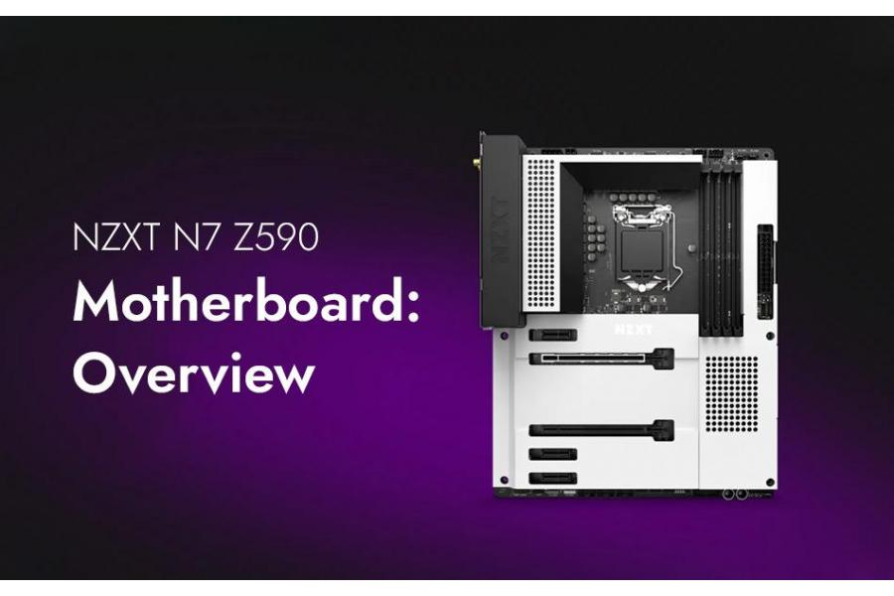

In a computer, the motherboard is the critical PCB (Printed Circuit Board) that connects all external devices and components. NZXT has released the N7 Z590 Intel Lake motherboard, which features adequate power supply, PCIe 4.0 support, Intel Wi-Fi 6E, and a unique design style that complements most themes. The motherboard has established itself as a serious contender in the mid-range market.

NZXT teamed up with ASRock to create this board, which appears to be based on the Z590 Steel Legend. The N7 Z590's unique-looking heatsinks/shrouds encompass the majority of the motherboard, giving it that characteristic NZXT appearance.

The Z590 class of NZXT's motherboards struggles to upgrade upon the last-gen and does so with confidence, despite the fact that you can't tell by looking at the motherboard. The N7 features a PCIe M.2 4.0 connector, a PCIe 4.0 slot, additional USB ports, improved power supply, and more. The details of this Motherboard Latest Version are listed below.

**Specifications:**

* LGA 1200 socket
* ATX form factor
* 2.5 GbE network jack
* SPDIF + 5 Analog audio jacks
* One v4.0 x16 PCIe (Peripheral Component Interconnect Express) x16
* One v3.0 x4 PCIe x16
* AMD CrossFire X
* Four DDR4 DIMM slots, 128GB Capacity
* Four SATA3 6 Gbps
* Seven 4-Pin pump headers
* TPM, FP-Audio
* Intel AX210 Wi-Fi 6
* ASMedia ASM1074 USB controllers
* Three years of warranty
* Two NZXT RGB headers
* Two USB v2.0
* 12-Phase voltage regulator

**Performance**

The N7 Z590 performs admirably when it comes to performance. In most tests, its results were tied with those of other motherboards. The Z590 adheres to Intel specifications, and its results in some tests (Cinebench/POV-Ray, Handbrake) were slightly worse than the others. Fine-tune the power restrictions, as other boards do, to improve this. The N7 set DDR4 3600 at 1:1 in the memory controller, and we saw good results in memory bandwidth and latency tests.

**What’s inside the box:**

* Motherboard Guide
* Four SATA Cables
* Wi-Fi Antenna
* Two screw packages for M.2 outlets

**Design**

After removing the box, we can see the 6-layer matte-black covered printed circuit board. We first notice NZXT branding on the back IO and top M.2 socket covers. The N7 Z590 doesn't include RGB lightning. You will continue the design and you'll see two RGB headers along with a dual NZXT RGB connector. This PCB looks premium and is the most enclosed.

The upper portion is quite plain. The IO cover on the left touches the left VRM bank (Voltage Regulator Modulator). Although the heatsink is not very large, it does a great job keeping the power bits cool. To provide power to the CPU, there are two EPS connectors located directly above the heatsink. Two 4-pin fan headers are located on the right. Each one can provide 24W of output.

Shrouds are the predominant welcome on the bottom half. The left side houses the ALC1220 Realtek codec, which has five audio caps. There are a few PCIe slots and M.2 sockets in the middle. The PCIe 4.0 top slot is capable of running a Rocket Lake-based CPU. There are several headers across the bottom of this board. These include additional USB ports. The list is shown below, from left to right.

* Front-panel audio
* ARGB and RGB headers
* UART header
* Three USB 2.0 header
* Q-Code LEDs
* USB 3.2 generation 1 connector

**Price Tag**

Demand has increased due to the Latest Motherboard News. It is possible to quickly obtain one for UK £210. The motherboard is well worth the price.

**Reasons to buy**

* Smart styling
* Wi-Fi 6E
* Micro buttons for reset and power
* Seven fan headers
* Improved power delivery

**Conclusive Thougts**

The NZXT N7 has excellent gaming characteristics. It has established itself in the gaming community. This mid-range motherboard has Intel Wi-Fi 6E, competent power delivery, and two M.2 ports, so it's worth a shot. Check out our website [subserve.co.uk](https://subserve.co.uk/) if you wish to order a motherboard.